Setup Visual Studio Code Apache Spark Environment

1. Install Python 3.7 - <https://www.python.org/downloads/release/python-377/>



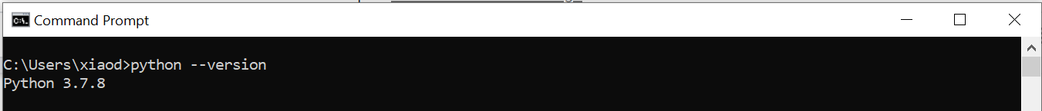

1. Install VS code editor & Python extension - [https://code.visualstudio.com](https://code.visualstudio.com/)



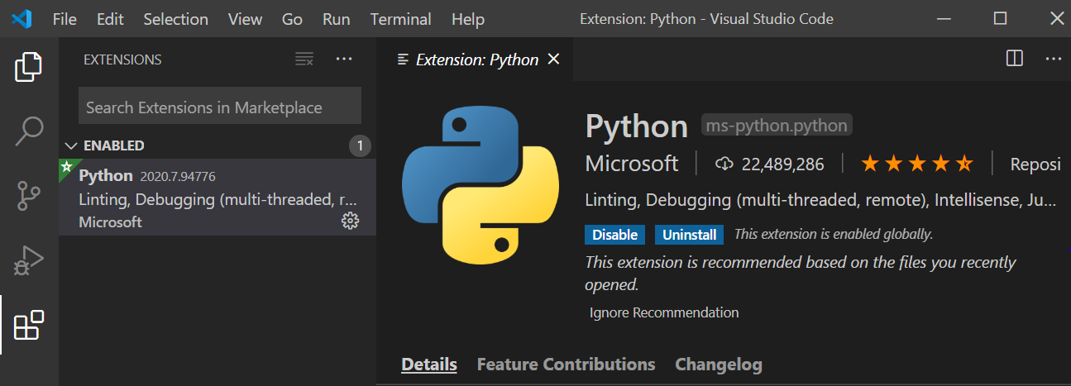

1. Install pyspark - pip install pyspark==2.4.6

